**BLUEWHALE.HTML**

<html>  
 <head>  
 </head>  
  
 <body style='background-color:#000000' href='gorgoroth.html'>  
 <a href='gorgoroth.html'>  
 <img src='blue_whale.png' style="position: absolute; margin: auto; top: 0; left: 0; right: 0; bottom: 0;"/>  
 </a>  
 </body>  
</html>

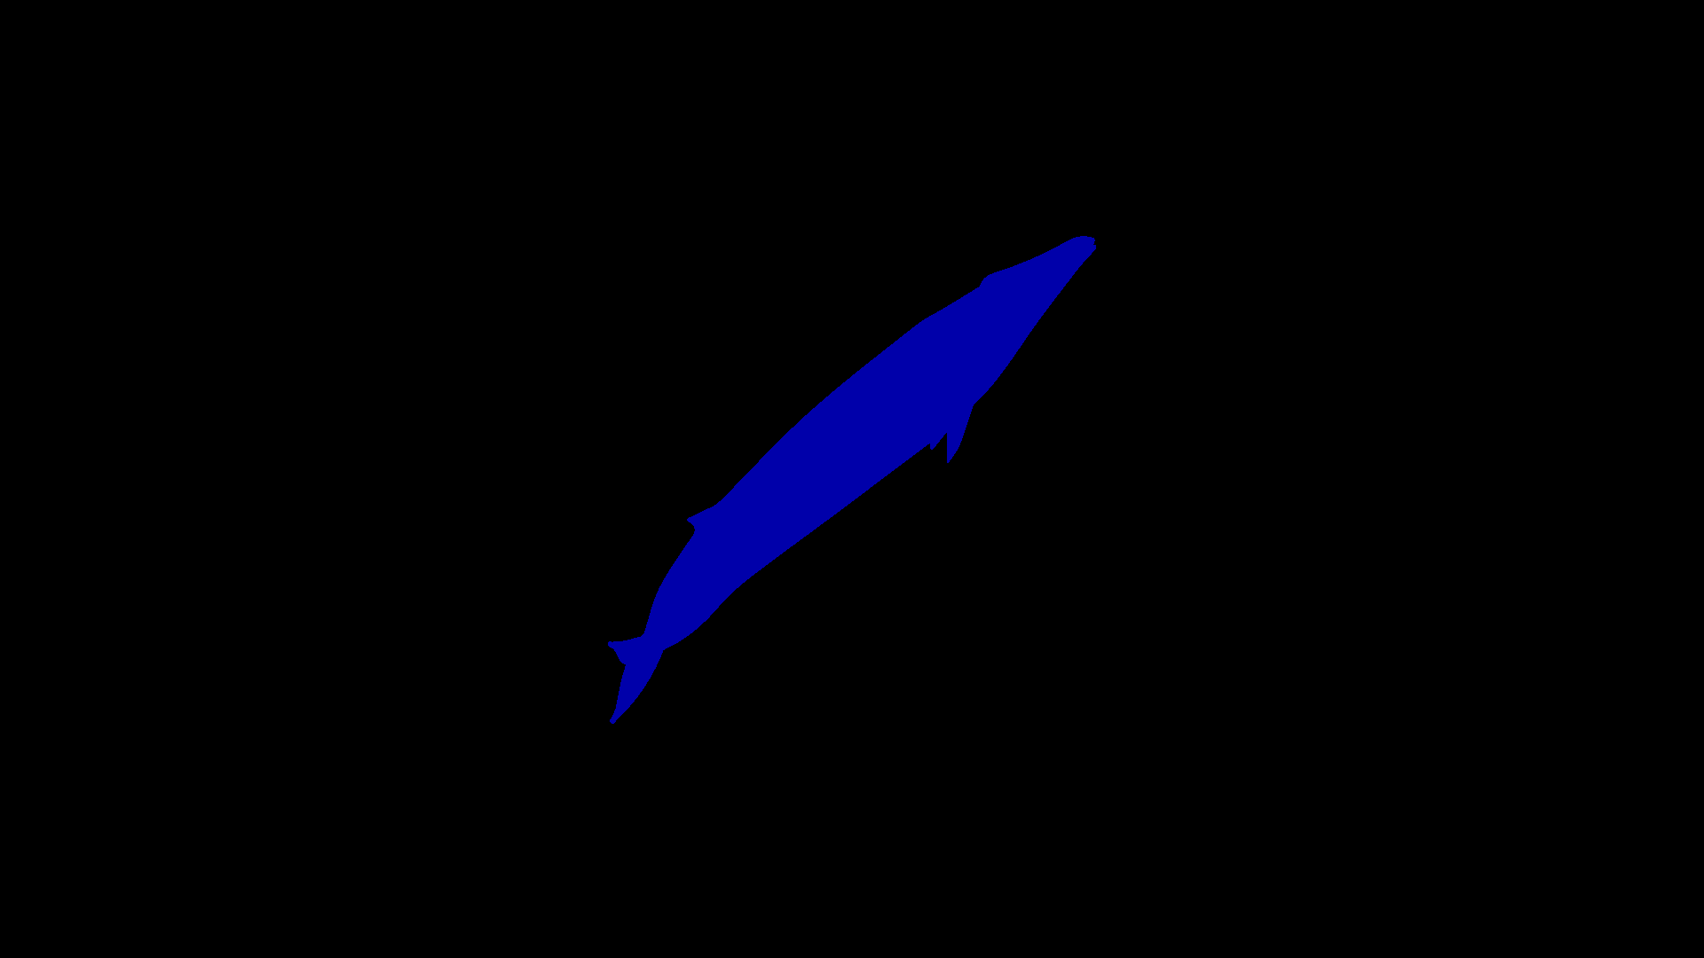

**GORGOROTH.HTML**

<html>  
 <head>  
 <style>  
 a {  
 color: #cc0000;  
 }  
 iframe {  
 width=100%;   
 margin-left: auto;   
 margin-right: auto;   
 }  
 </style>  
 </head>  
 <body style='background-color:#000000'>  
 <center>  
 <iframe width="560" height="315" src="https://www.youtube.com/embed/ngn8sJRAvNM" frameborder="0"   
 allow="accelerometer; autoplay; encrypted-media; gyroscope; picture-in-picture" allowfullscreen></iframe>  
 </center>  
 <center>  
 <a href='https://youtu.be/ngn8sJRAvNM'>Kamlesh</a>  
 </center>  
 <br/>  
 <center>  
 <iframe width="560" height="315" src="https://www.youtube.com/embed/g7yxjTcM7Bs" frameborder="0" allow="accelerometer; autoplay; encrypted-media; gyroscope; picture-in-picture" allowfullscreen></iframe>  
 </center>  
 <center>  
 <a href='https://www.youtube.com/watch?v=g7yxjTcM7Bs'>Wolves ov Siberia</a>  
 </center>  
 <br/>  
 <center>  
 <iframe width="560" height="315" src="https://www.youtube.com/embed/bt7UurVmS54" frameborder="0" allow="accelerometer; autoplay; encrypted-media; gyroscope; picture-in-picture" allowfullscreen></iframe>  
 </center>  
 <center>  
 <a href='https://www.youtube.com/watch?v=bt7UurVmS54'>Elfen lied</a>  
 </center>  
 <br/>  
 <br/>  
 <center>  
 <div>  
 <a href='hellgirl.html'>  
 <img href='hellgirl.html' src='blue_whale.png'/>  
 </a>  
 </div>  
 </center>  
 </body>  
</html>

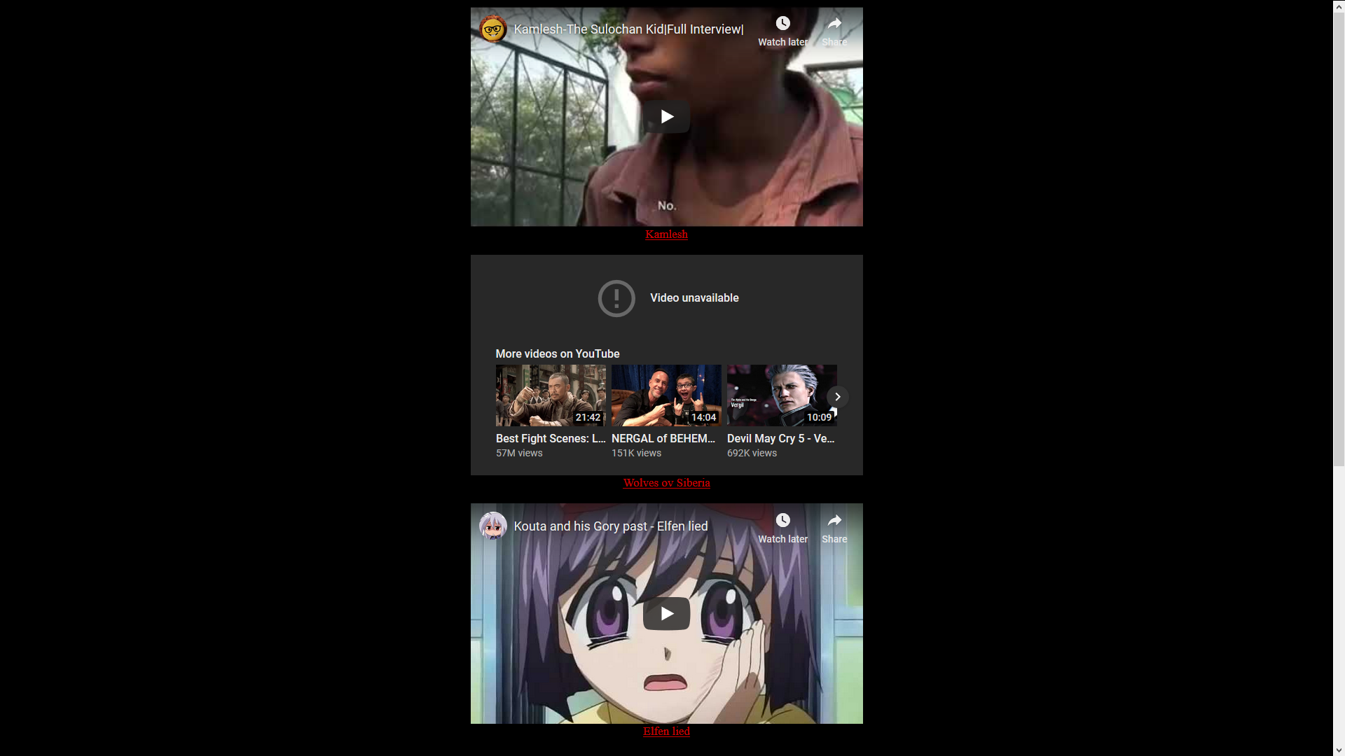

**HELLGIRL.HTML**

<html>  
 <head>  
 <style>  
 input {  
 color: #880000;  
 word-wrap: break-word;  
 word-break: break-all;  
 height: 40px;  
 width: 400px;  
 }  
 </style>  
 <script type='text/javascript'>  
 window.onload = function() {  
 var today = new Date();  
 var h = getHours();  
 var m = getMinutes();  
 if (h==0 && m==0){  
 //TODO: open web site  
 } else {  
 window.open("https://www.thebluewhalechallenge.com/","_self")  
 }  
 };  
  
 function submit() {  
 var enemy = document.forms["form"]["enemy"].value;  
 var contact = document.forms["form"]["contact"].value;  
 if (contact=="") {  
 alert('She might kill YOU!')  
 } else {  
 // TODO : add to database }  
 </script>  
 </head>  
  
 <body style='background-color: #000000' >  
 <form name='form' onsubmit='return submit()' method="post">  
 <center>  
 <input type=text name='enemy' placeholder='Who do you hate?'/>  
 </center>  
 <center>  
 <input type=text name='contact' placeholder='Your contact information for Hellgirl' required/>  
 </center>  
 <center>  
 <input type=submit value='Submit'/>  
 </center>  
 </form> <br/>  
 <br/>  
 <center>  
 <a href='https://woebot.io'>  
 <img src='blue_whale.png'/>  
 </a>  
 </center>  
 </body>  
</html>

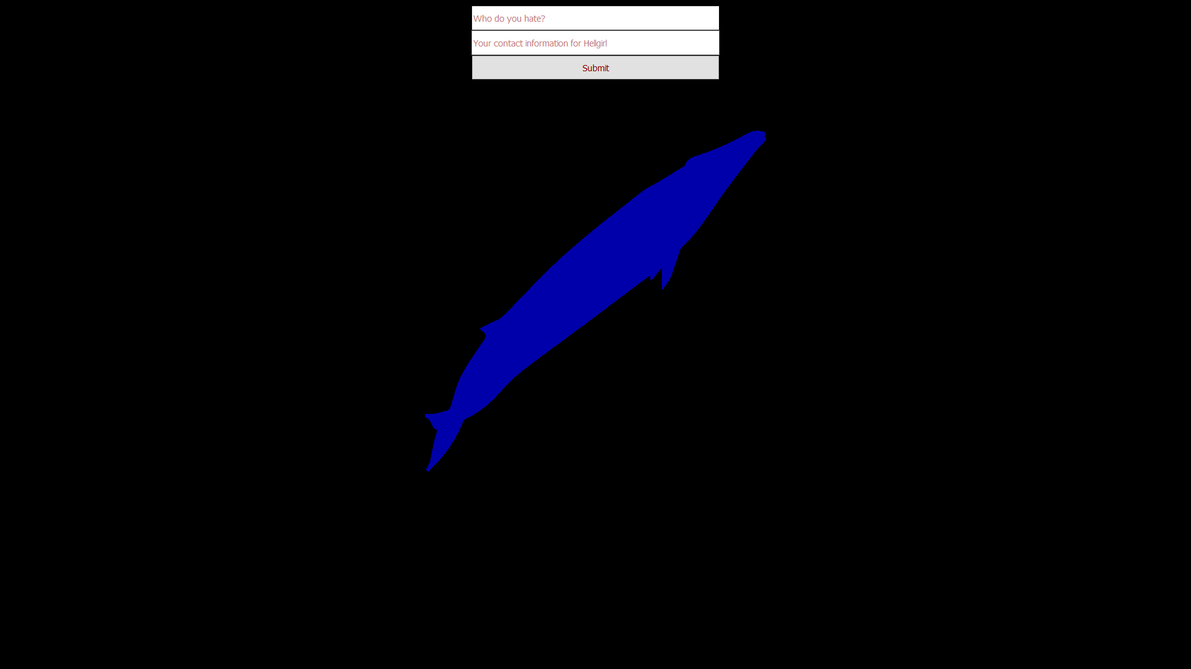

On clicking on the whale...

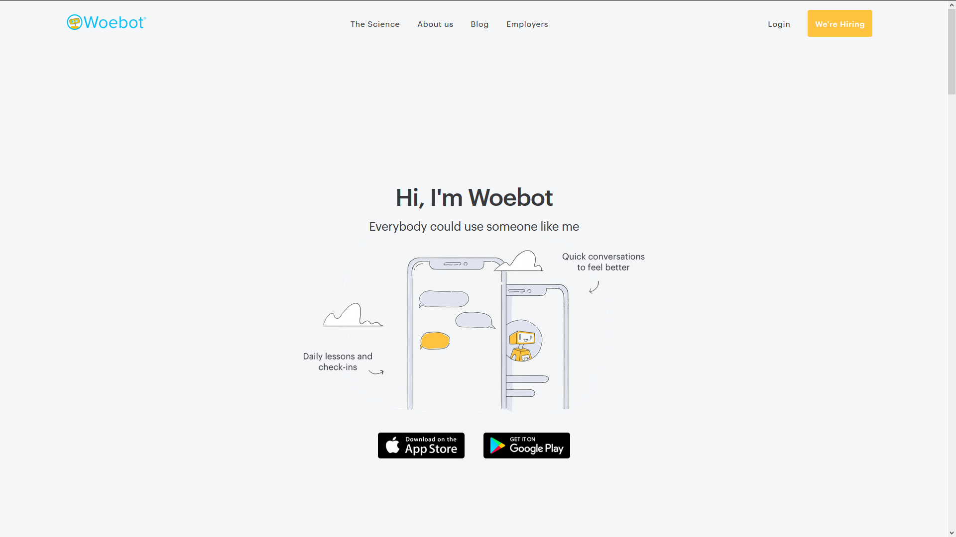

**S.JS**

var express = require('express');  
var app = express();  
  
app.get('/', function(req, res){  
 var today = new Date()  
 h = today.getHours()  
 m = today.getMinutes()  
 if ((h==12 || h==24 || h==0) && m==0){  
  
 } else   
 res.send("Try again at 1");  
});  
  
app.listen(3000);